JS Applications Exam – Pet Care
You are assigned to implement a Web application (SPA) using JavaScript. The application should dynamically display content, based on user interaction, and support user profiles and CRUD operations, using a REST service.
Only the last submission will be evaluated!

Overview
Implement a front-end application (SPA) to see and manage the pet. The app allows visitors to browse different pets, including their names, breed, and age. Users can register and login with an email and password, which allows them to create their pet postcard. Pets creators can also edit or delete their posts at any time.
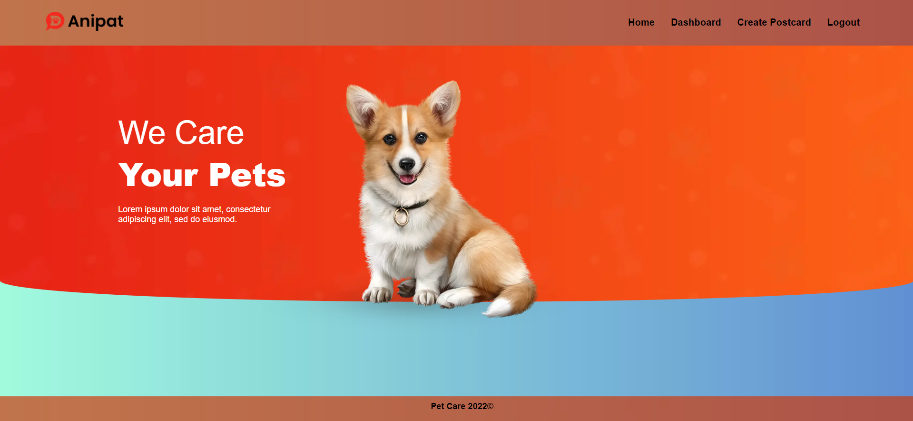

Technical Details
You are provided with the following resources:
- Project scaffold: A package.json file, containing a list of common dependencies. You may change the included libraries to your preference. The sections devDependencies and scripts of the file are used by the automated testing suite, altering them may result in incorrect test operation.
To initialize the project, execute the command npm install via the command-line terminal.
- HTML and CSS files: All views (pages) of the application, including sample user-generated content, are included in the file index.html, which links to CSS and other static files. Each view is in a separate section of the file, which can be identified by a unique class name or id attribute. Your application may use any preferred method (such as a templating library or manual visibility settings) to display only the selected view and to navigate between views upon user interaction.
- Local REST service: A special server, which contains sample data and supports user registration and CRUD operations via REST requests is included with the project. Each section of this document (where applicable) includes details about the necessary REST endpoints, to which requests must be sent, and the shape of the expected request body.
For more information on how to use the included server, see Appendix A: Using the Local REST Service at the end of this document.
- Automated tests: A complete test suite is included, which can be used to test the correctness of your solution. Your work will be assessed, based on these tests.
For more information on how to run the tests, see Appendix B: Running the Test Suite at the end of this document

Do not use CDN for loading the dependencies because it can negatively affect the tests!
Working with Remote Data
For the solution of some of the following tasks, you will need to use an up-to-date version of the local REST service, provided in the lesson’s resources archive. You can read the documentation here.
Note: When creating HTML Elements and displaying them on the page, adhere as closely as possible to the provided HTML samples. Changing the structure of the document may prevent the tests from running correctly, which will adversely affect your assessment grade. You may add attributes (such as class and dataset) to any HTML Element, as well as change "href" attributes on links and add/change the method and action attributes of HTML Forms, to facilitate the correct operation of a routing library or another method of abstraction. You may also add hidden elements to help you implement certain parts of the application requirements.

Application Requirements

Navigation Bar (5 pts)
Navigation links should correctly change the current page (view). The Home link should redirect to the Home page. Guests (unauthenticated visitors) can see the links to the Home, Dashboard, Login, and Register page. The logged-in user navbar should contain the links to the Home, Dashboard, Create Postcard page, and a link for the Logout action.
Guest navigation example:
User navigation example:

Login User (5 pts)
The included REST service comes with the following premade user accounts, which you may use for development:
{ "email": "peter@abv.bg", "password": "123456" }
{ "email": "john@abv.bg", "password": "123456" }
The Login page contains a form for existing user authentication. By providing an email and password, the app should login a user into the system if there are no empty fields.
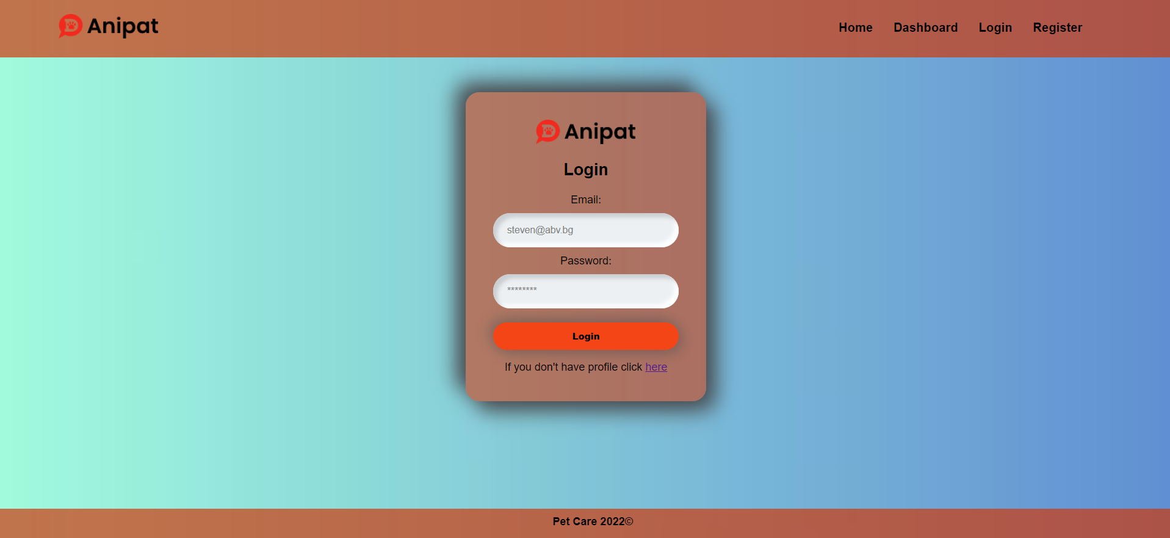
Send the following request to perform login:
Method: POST
URL: /users/login
Required headers are described in the documentation. The service expects a body with the following shape:
{
email,
password
}
Upon success, the REST service will return information about the existing user along with a property accessToken, which contains the session token for the user – you need to store this information using sessionStorage or localStorage, to be able to perform authenticated requests.
If the login was successful, redirect the user to the Home page. If there is an error, display an appropriate error message, using a system dialog (window.alert).

Register User (10 pts)
The Register page contains a form for new user registration. By providing an email and password, the app should register a new user in the system if there are no empty fields.
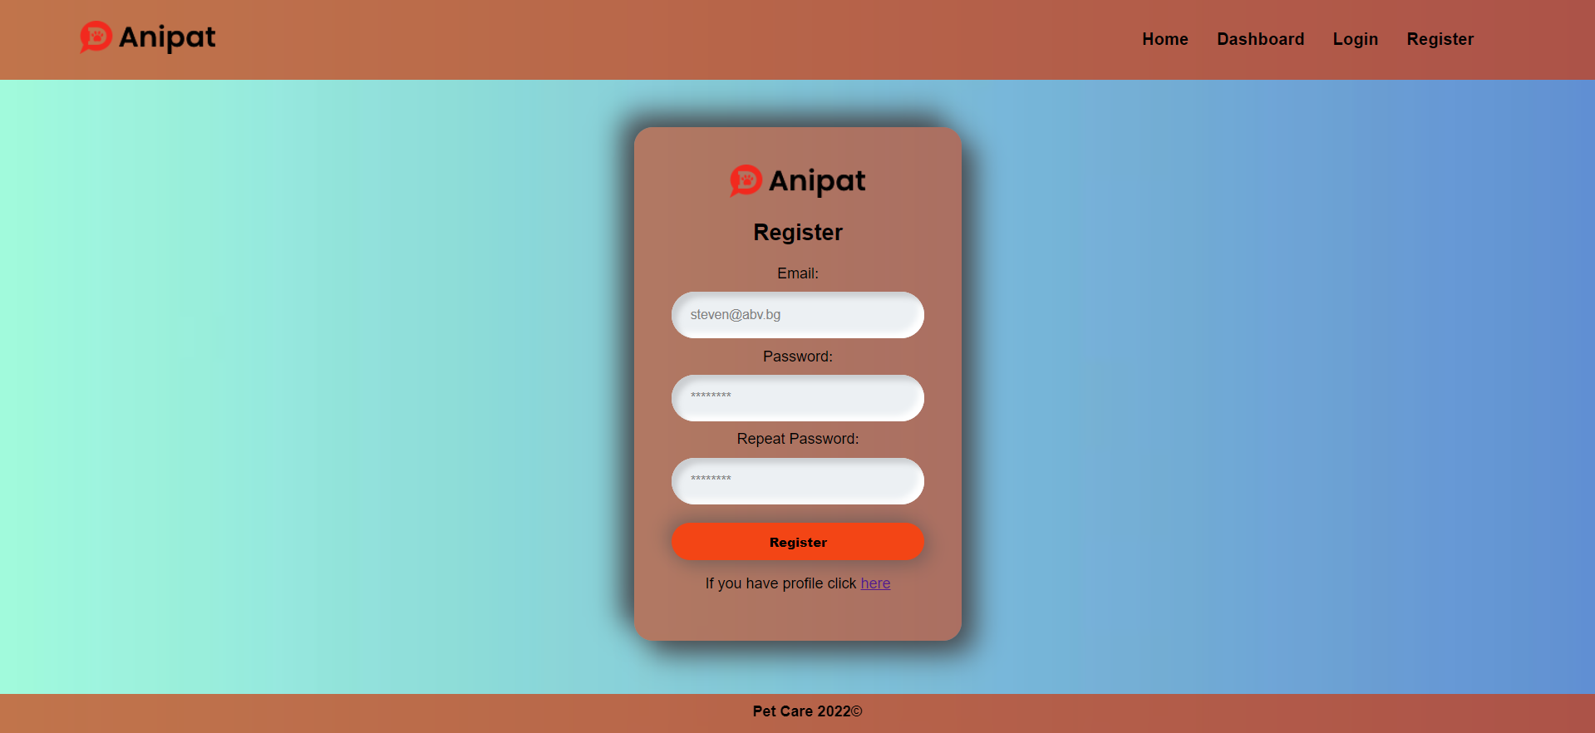
Send the following request to perform registration:
Method: POST
URL: /users/register
Required headers are described in the documentation. The service expects a body with the following shape:
{
email,
password
}
Upon success, the REST service will return the newly created object with an automatically generated _id and a property accessToken, which contains the session token for the user – you need to store this information using sessionStorage or localStorage, to be able to perform authenticated requests.
If the registration was successful, redirect the user to the Home page. If there is an error, or the validations don’t pass, display an appropriate error message, using a system dialog (window.alert).

Logout (5 pts)
The Logout action is available to logged-in users. Send the following request to perform logout:
Method: GET
URL: /users/logout
Required headers are described in the documentation. Upon success, the REST service will return an empty response. Clear any session information you’ve stored in browser storage.
If the logout was successful, redirect the user to the Home page.

Home Page (10pts)
All users should be greeted from the homepage. There is a static page:
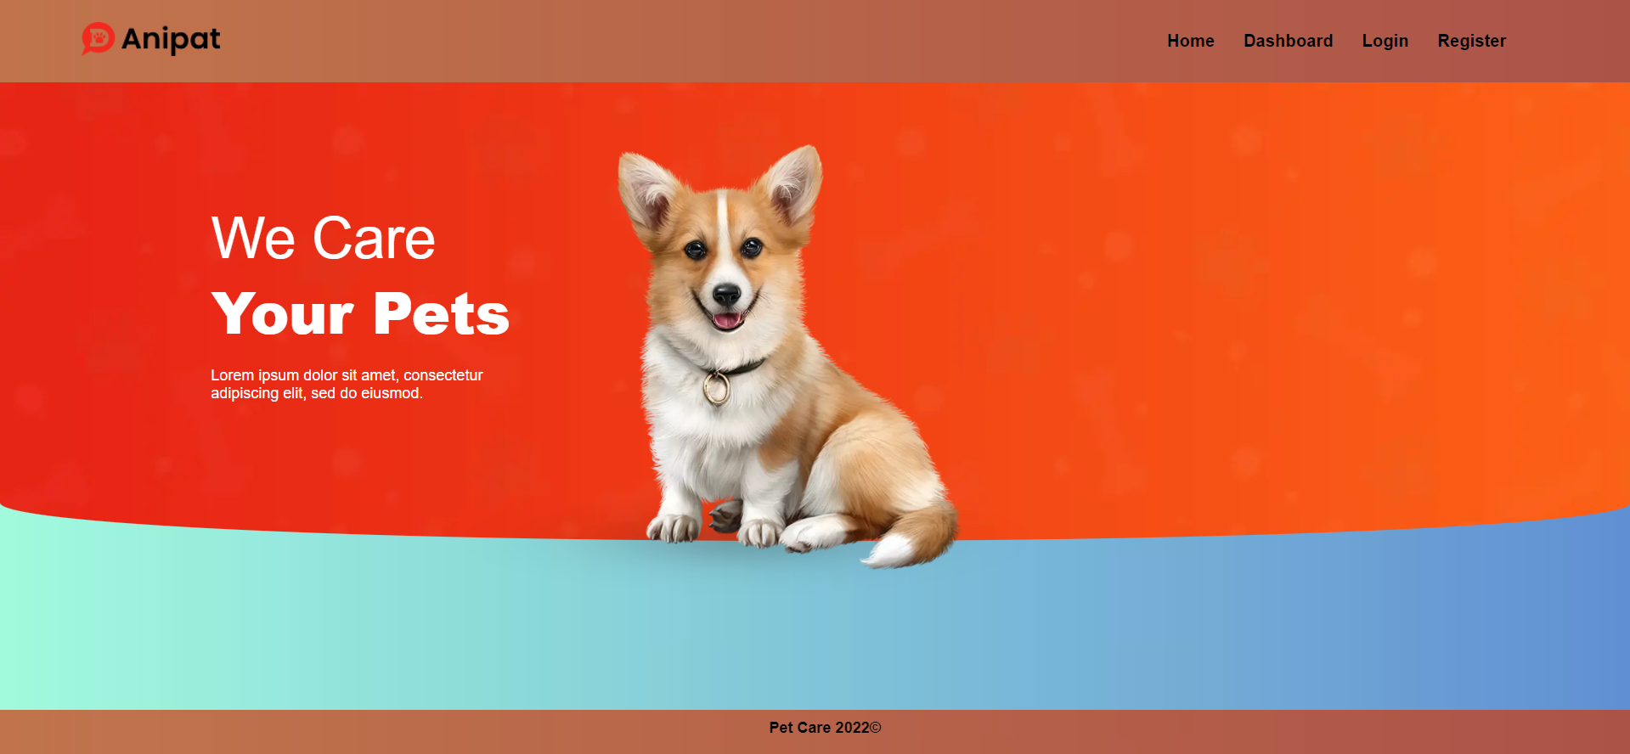

Dashboard Page (15 pts)
The Home Page displays a list of all pets in the system. All users should be seeing the list and have access to Details Page.
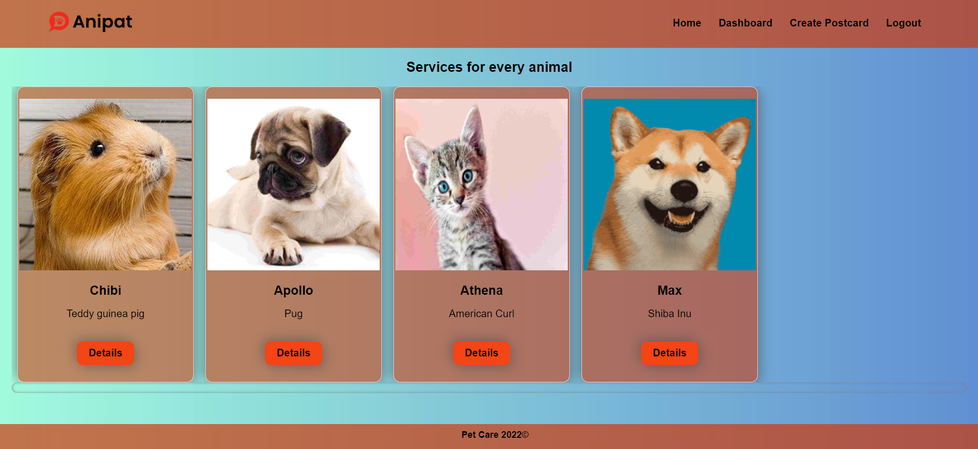
If there are no pets yet, the following view should be displayed:
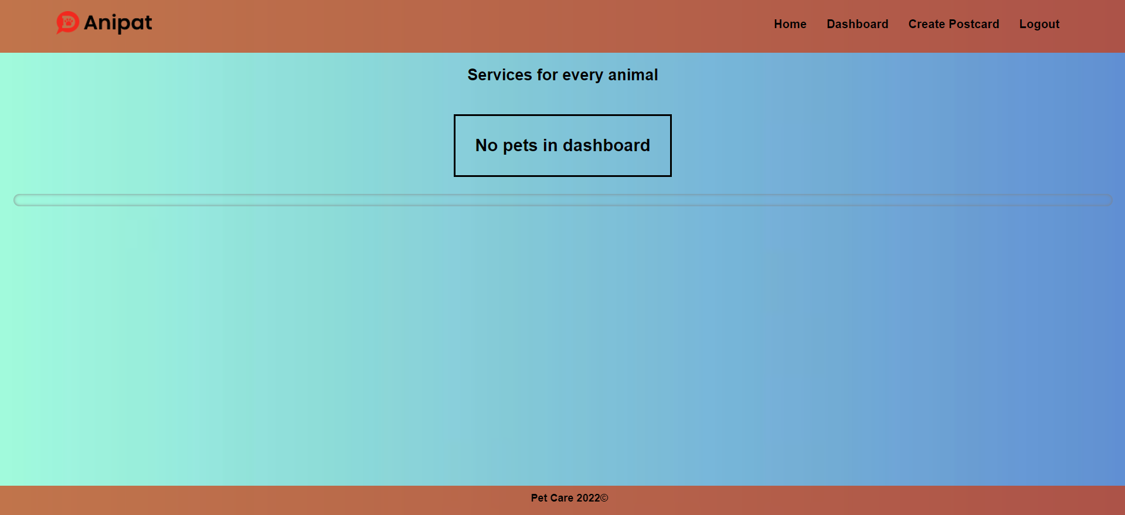
Send the following request to read the list of pets:
Method: GET
URL: /data/pets?sortBy=_createdOn%20desc&distinct=name
Required headers are described in the documentation. The service will return an array of pets.

Create Page (15 pts)
The Create page is available to logged-in users. It contains a form for creating a new pet postcard. Check if all the fields are filled out before you send the request.
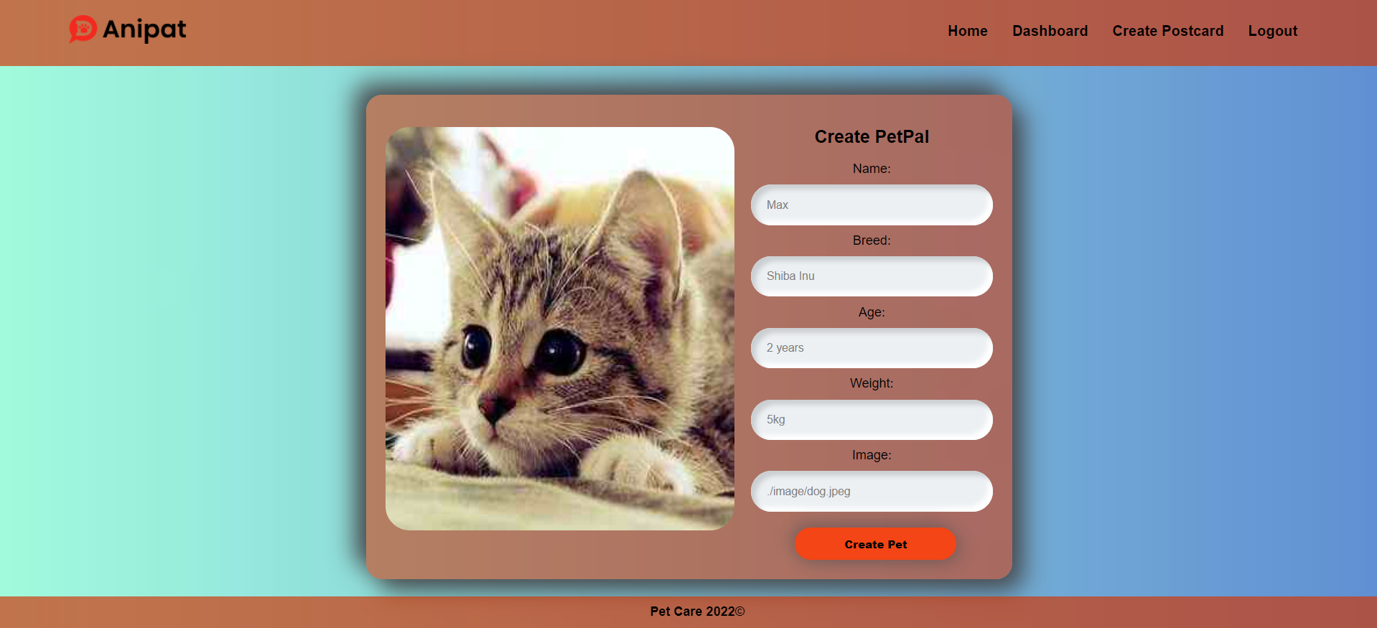
To create a pet, send the following request:
Method: POST
URL: /data/pets
Required headers are described in the documentation. The service expects a body with the following shape:
{
name,
breed,
age,
weight,
image
}
The service will return the newly created record. Upon success, redirect the user to the Home page.

Details (10 pts)
Logged-in users should be able to view details about pets. Clicking the Details link in a pet should display the Details page. If the currently logged-in user is the creator of the pet postcard, the Edit and Delete buttons should be displayed. 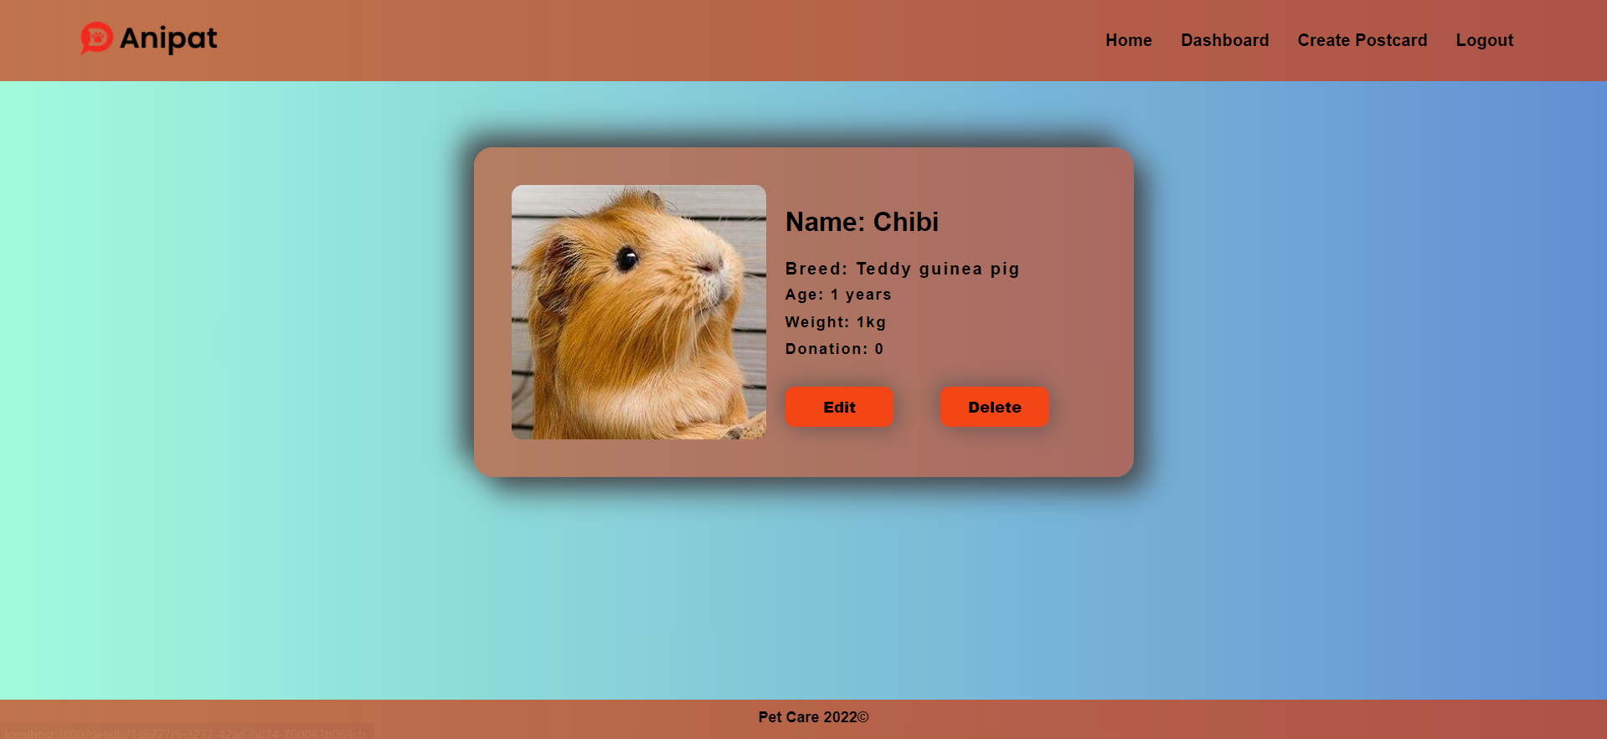

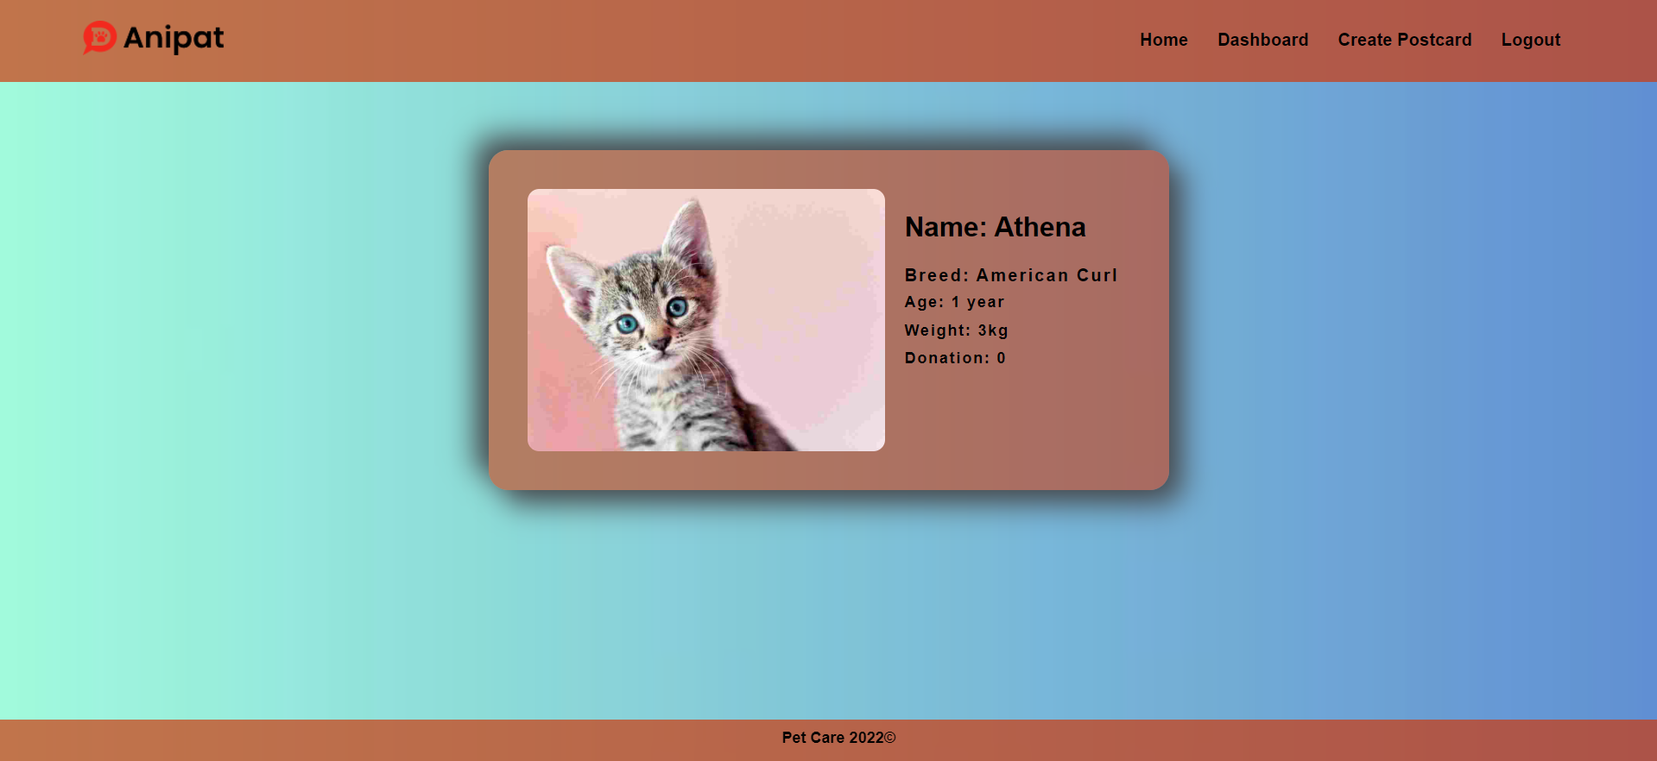
If there is no logged-in user the details page should look like this:
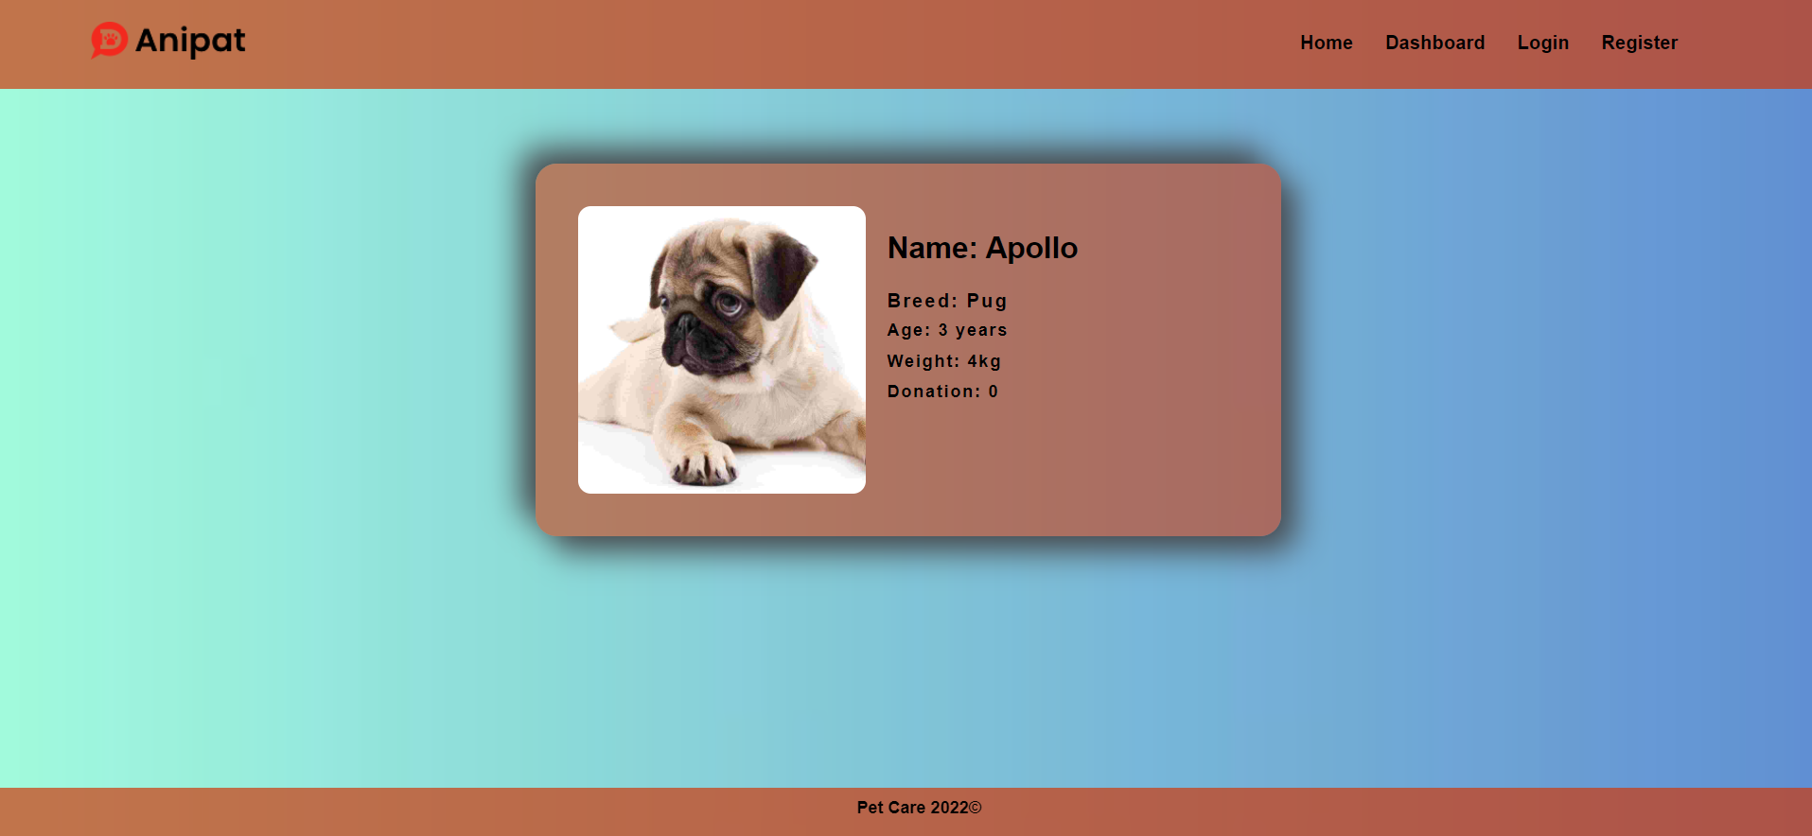
Send the following request to read a single pet:
Method: GET
URL: /data/pets/:id
Where :id is the id of the desired pet. Required headers are described in the documentation. The service will return a single object.

Edit Page (15 pts)
The Edit page is accessible to logged-in users and allows the author to edit their pet postcard. Clicking the Edit button on the details page of a specific pet postcard should display the Edit page. It contains a form with input fields for all relevant properties. Make sure all fields are filled in before submitting the request. The fields must be filled in with the previous data when the page is first loaded.
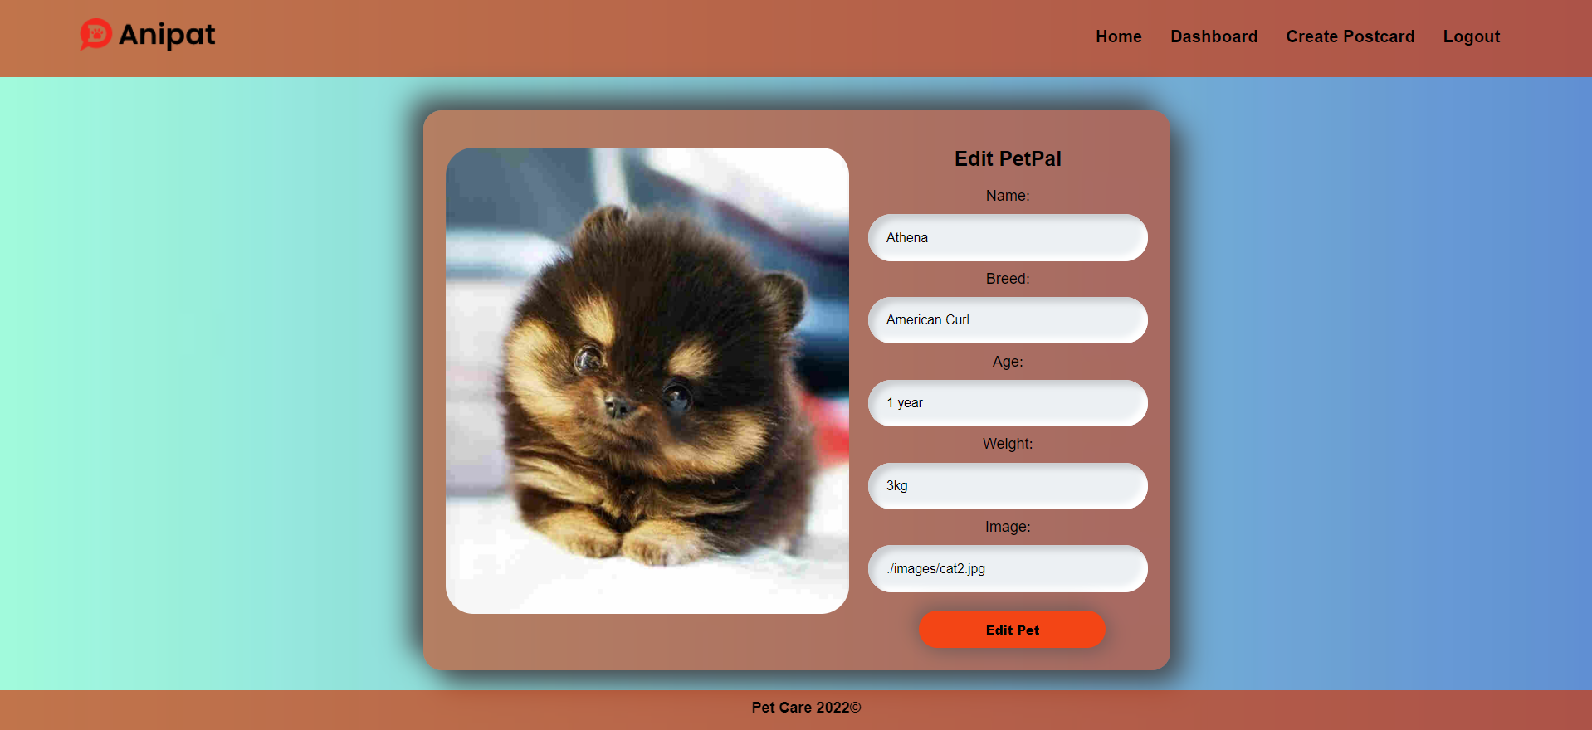
To edit a pet, send the following request:
Method: PUT
URL: /data/pets/:id
Where :id is the id of the desired pet postcard.
The service expects a body with the following shape:
{
name,
breed,
age,
weight,
image
}
Required headers are described in the documentation. The service will return the modified record. Note that PUT requests do not merge properties and will instead replace the entire record. Upon success, redirect the user to the Details page.

Delete Article (10 pts)
The Delete action is available to logged-in users, for pets they have created. When the author clicks on the Delete action on any of their pets, a confirmation dialog should be displayed, and upon confirming this dialog, the pet should be deleted from the system.
To delete a pet, send the following request:
Method: DELETE
URL: /data/pets/:id
Where :id is the id of the desired pet. Required headers are described in the documentation. The service will return an object, containing the deletion time. Upon success, redirect the user to the Home page.

(BONUS) Donate Action (15 pts)
Every logged-in user should be able to donate to other pets, but not his own. By clicking on the [Donate] button, the donation of each pet increases by 100. ( You need to multiply the counter of each pet donation by 100 )
The view when the user did not press the [Donation] button should look like this:
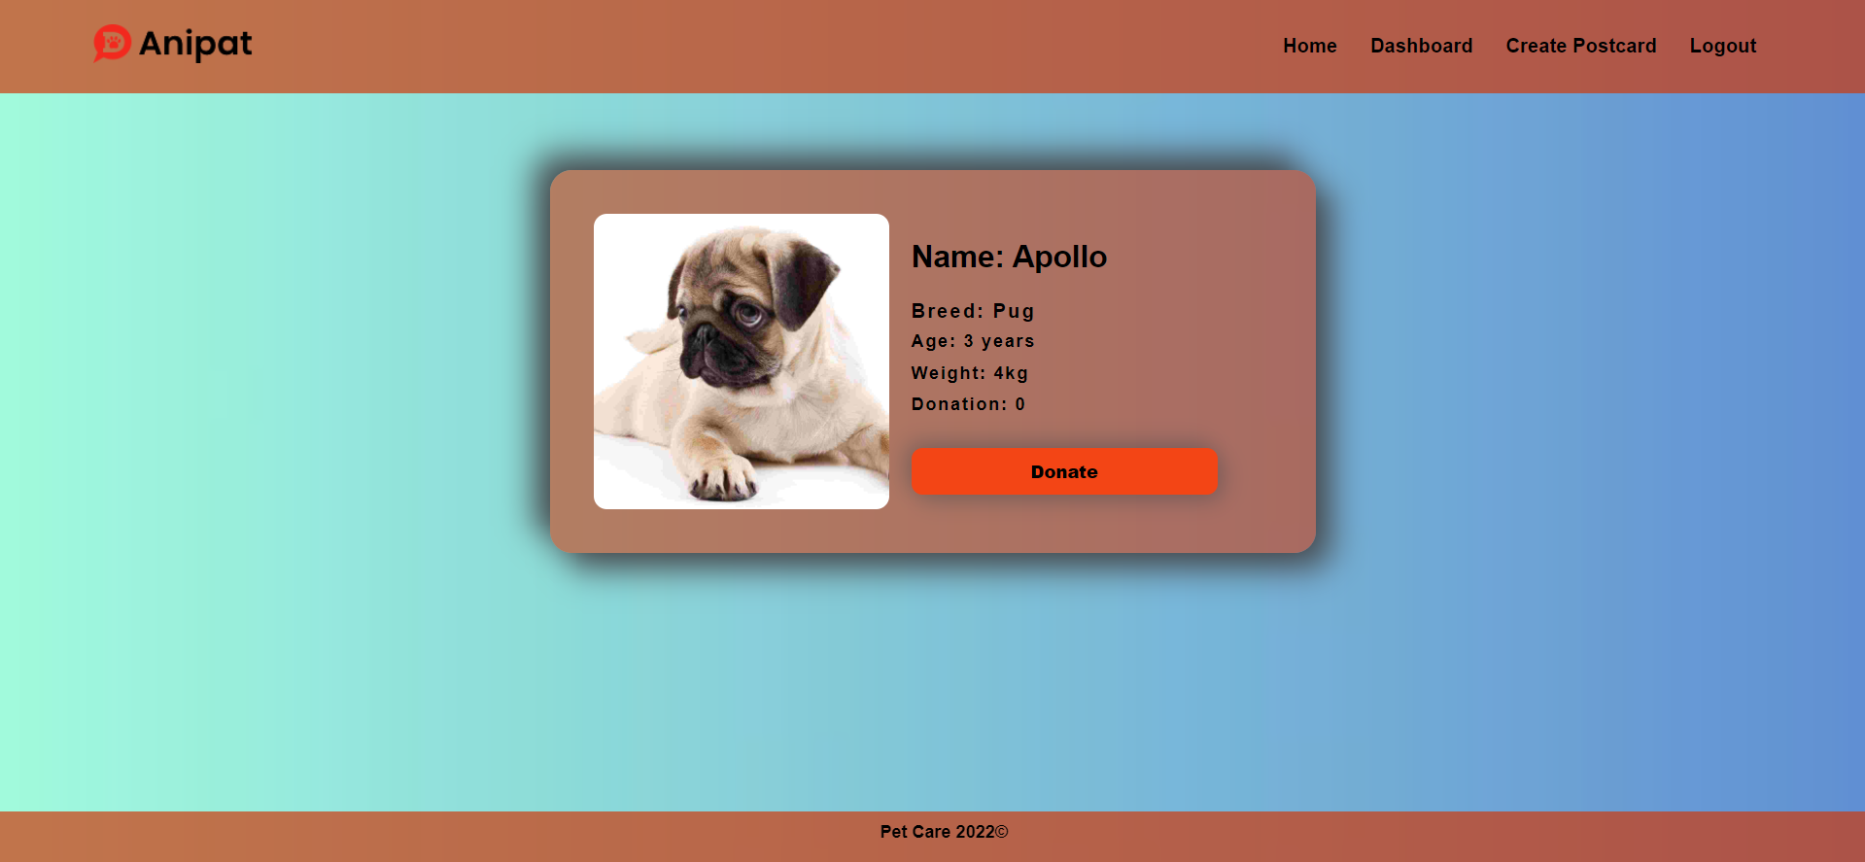
When the user Donation for a pet the [Donation] button should not be available and the counter should be increased by 100.
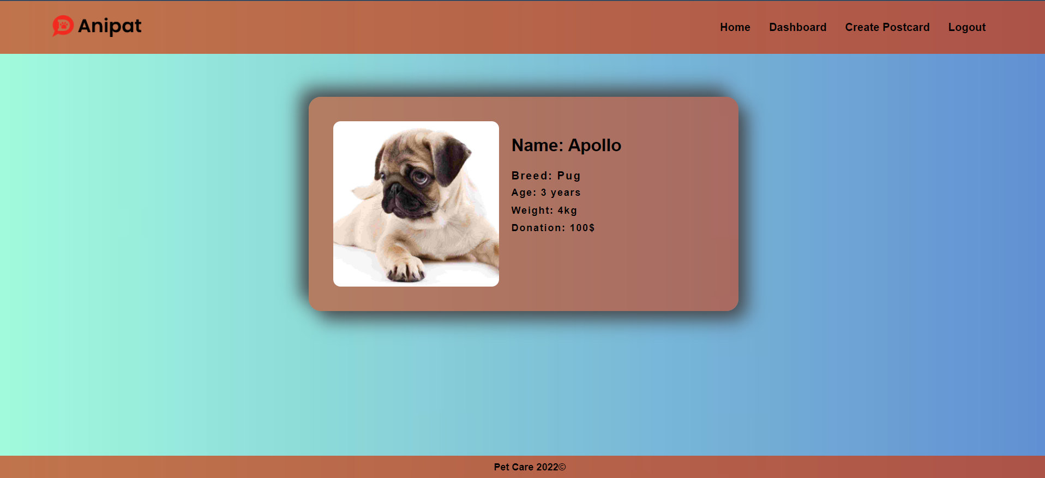
The creator should not be able to see the [Donation] button. The view should look like this:
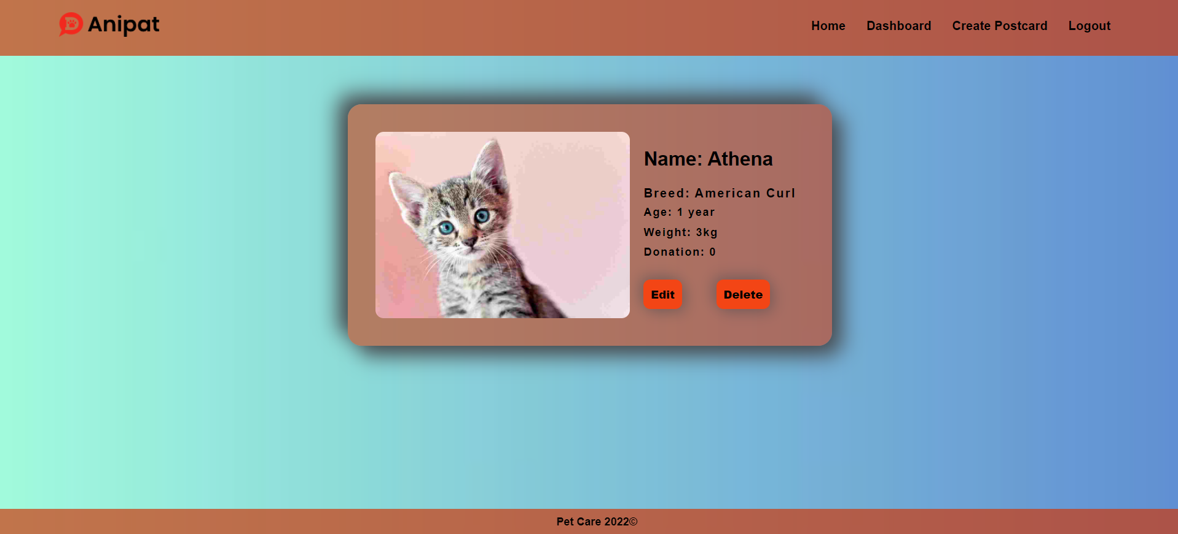

Guest should not be able to see the [Donate] button. The view for guests should look like this:
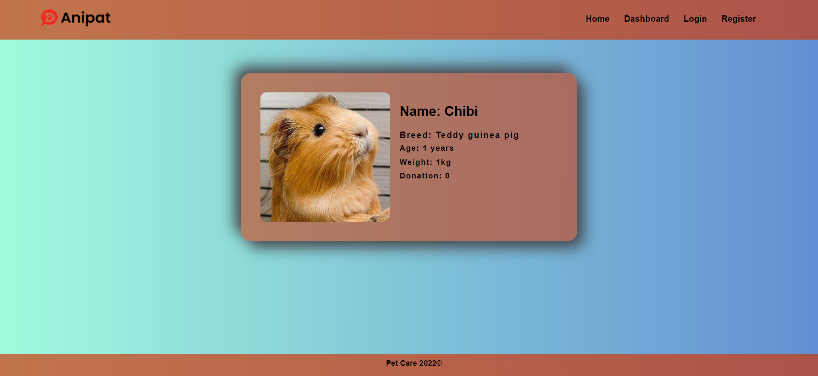
Send the following request to add a donation:
Method: POST
URL: /data/donation
The service expects a body with the following shape:

{
petId
}
Required headers are described in the documentation. The service will return the newly created record.
Send the following request to get the total donation count for a pet:
Method: GET
URL: /data/donation?where=petId%3D%22${petId}%22&distinct=_ownerId&count
Where {petId} is the id of the desired pet. Required headers are described in the documentation. The service will return the total donations count.
Send the following request to get a donation for a pet from a specific user:
Method: GET
URL:/data/donation?where=petId%3D%22${petId}%22%20and%20_ownerId%3D%22${userId}%22&count
Where {petId} is the id of the desired pet and {userId} is the id of the currently logged-in user.
Required headers are described in the documentation. The service will return either 0 or 1. Depending on that result the [Donation] button should be displayed or not.

Submitting Your Solution
Place in a ZIP file your project folder. Exclude the node_modules. Upload the archive to Judge.
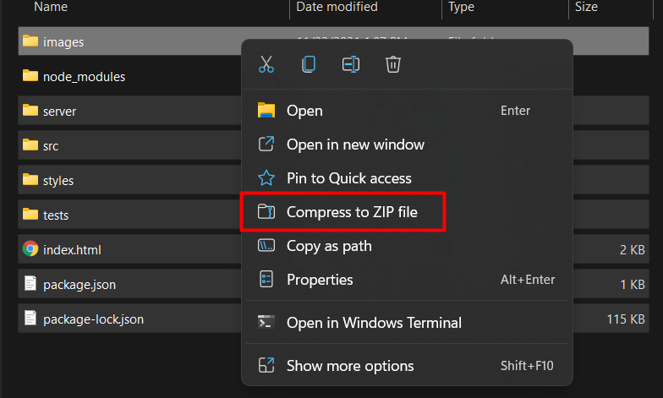
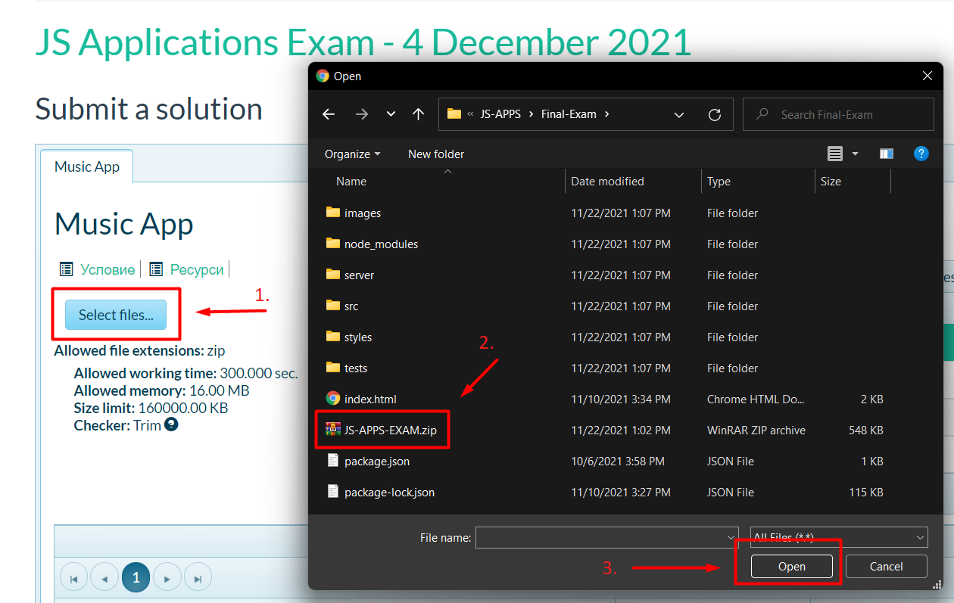
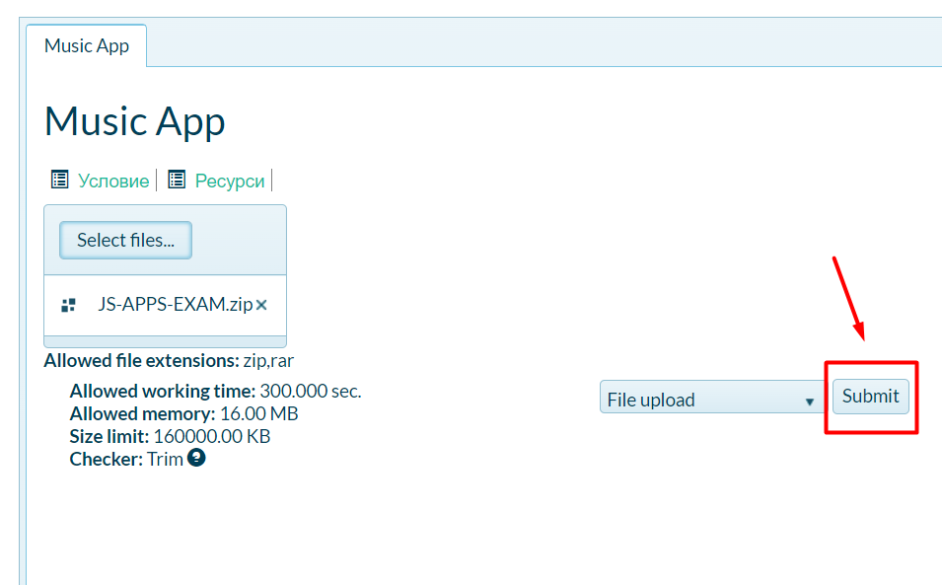
It will take several minutes for Judge to process your solution!
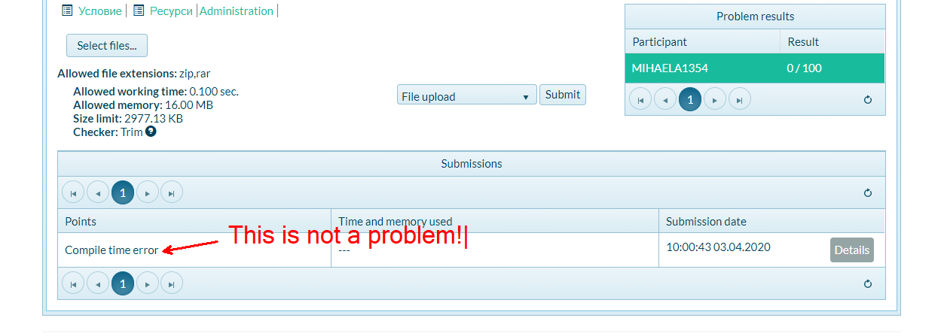

Appendix A: Using the Local REST Service

Starting the Service
The REST service will be in a folder named “server” inside the provided resources archive. It has no dependencies and can be started by opening a terminal in its directory and executing:
node server.js
If everything is initialized correctly, you should see a message about the host address and port on which the service will respond to requests.

Sending Requests
To send a request, use the hostname and port, shown in the initialization log and resource address and method as described in the application requirements. If data needs to be included in the request, it must be JSON-encoded, and the appropriate Content-Type header must be added. Similarly, if the service is to return data, it will be JSON-encoded. Note that some requests do not return a body and attempting to parse them will throw an exception.
Read requests, as well as login and register requests, do not require authentication. All other requests must be authenticated.

Required Headers
To send data to the server, include a Content-Type header and encode the body as a JSON string:
Content-Type: application/json
{JSON-encoded request body as described in the application requirements}
To perform an authenticated request, include an X-Authorization header, set to the value of the session token, returned by an earlier login or register request:
X-Authorization: {session token}

Server Response
Data response:
HTTP/1.1 200 OK
Access-Control-Allow-Origin: *
Content-Type: application/json
{JSON-encoded response data}
Empty response:
HTTP/1.1 204 No Content
Access-Control-Allow-Origin: *
Error response:
HTTP/1.1 400 Request Error
Access-Control-Allow-Origin: *
Content-Type: application/json
{JSON-encoded error message}

More Information
You can find more details on the GitHub repository of the service.

Appendix B: Running the Test Suite

Project Setup
The tests require a web server to deliver the content of the application. There is a development web server included in the project scaffold, but you may use whatever server you are familiar with. Note that specialized tools like BrowserSync may interfere with the tests. To initialize the project with its dependencies, open a terminal in the folder, containing the file package.json and execute the following:
npm install
Note that if you changed the section devDependencies of the project, the tests may not initialize properly.
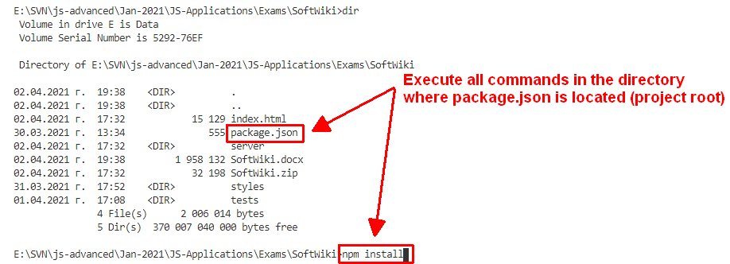

Executing the Tests
Before running the test suite, make sure a web server is operational, and the application can be found at the root of its network address. To start the included dev-server, open a terminal in the folder containing package.json and execute:
npm run start
This is a one-time operation unless you terminate the server at any point. It can be restarted with the same command as above.
To execute the tests, open a new terminal (do not close the terminal, running the web server instance) in the folder containing package.json and execute:
npm run test
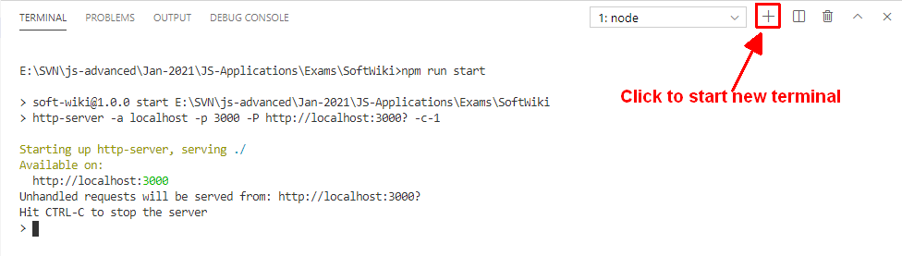
Test results will be displayed in the terminal, along with detailed information about encountered problems. You can perform this operation as many times as it is necessary by re-running the above command.

Debugging Your Solution
If a test fails, you can view detailed information about the requirements that were not met by your application. Open the file e2e.test.js in the folder tests and navigate to the desired section as described below.
This first step will not be necessary if you are using the included web server. Make sure the application host is set correctly:
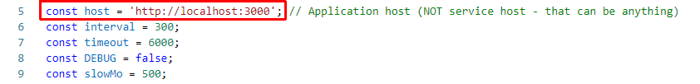
The value for the host must be the address where your application is being served. Make sure that entering this address in a regular internet browser shows your application.
To make just a single test run, instead of the full suite (useful when debugging a single failing test), find the test and append .only after it reference:
On slower machines, some of the tests may require more time to complete. You can instruct the tests to run more slowly by slightly increasing the values for interval and timeout:
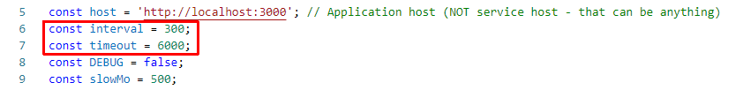
Note that interval values greater than 500 and timeout values greater than 10000 are not recommended.
If this doesn’t make the test pass, set the value of DEBUG to true and run the tests again – this will launch a browser instance and allow you to see what is being tested, what the test sees, and where it fails (or hangs):
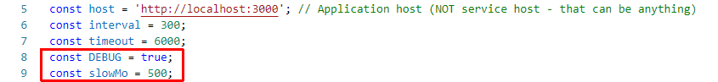
If the actions are happening too fast, you can increase the value of slowMo. If the browser hangs, you can just close it and abort any remaining tests by focusing on the terminal window and pressing [Ctrl+C] followed by the letter "y" and [Enter].
The final thing to look for is the exact row where the test fails:
